Minden State School
Uniform Dress Code
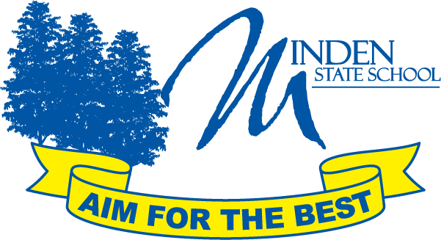

The Minden State School community strongly advocates the universal wearing of school uniforms by students in
Prep to Year 6. This code has been endorsed by the school’s Parents and Citizens Association.

The wearing of the school uniform supports:
- A safe learning environment by enabling ready identification of students;
- A sense of belonging and minimizing visible evidence of economic or social difference.
- The elimination of competition in dress / fashion at school;

Students are expected to wear school uniform when:
- Attending or representing the school;
- Participating in school excursions and field trips;
- Travelling to and from school; or
- Engaging in school activities and events out of school hours.

The school uniform, as currently adopted by the P&C, is as follows:

Girls Uniform  Checked dress OR  Royal Blue polo shirt  Royal blue shorts / skort / skirt  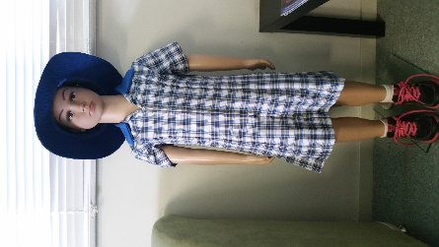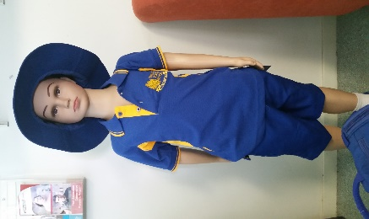 | Boys Uniform  Royal Blue polo shirt  Royal blue shorts  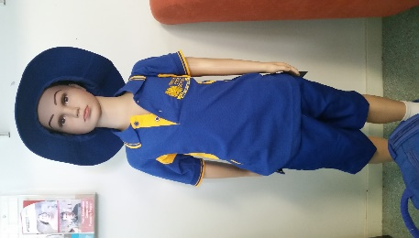
Winter Uniform:
As above with Royal Blue tracksuit coat, track pants, beanies, scarves, gloves.

Hat : Royal Blue wide brim OR bucket hat

Shoes: closed toe and heel - either black leather school shoes OR joggers (any colour), laces securely tied. Velcro straps are also permitted.

Hair: Shoulder length hair (or longer) is to be plaited, braided or tied back with appropriate accessories. Coloured hair or inappropriate hairstyles are not appropriate e.g. mohawk, shaved head, ombre, balayage.
Hair accessories: small hair tie, ribbon, clips, bobby pins, head band in school colours of royal blue or neutral.

Jewellery: Watch, Earrings – small plain sleeper or stud,
Medical alert bracelet or necklace
Items of significant religious belief or personal sentiment as negotiated with administration

Nail polish: Clear nail polish only on own nails.

All summer and winter uniform items, except for hair accessories and shoes, can be purchased from the Uniform Shop.
Second-hand items are also available.

